WHO ARE CHARLIE AND JILL LEBLANC

Serving the Lord together in music ministry for over 40 years, the heart of Charlie & Jill’s ministry is to encourage and empower people through their music and teachings, helping Christians step up and become more useable by the Lord. Their songs, their writings and their talks are all Bible based, endeavoring to reveal God as much bigger than life’s difficulties.

For years Charlie & Jill have faithfully served the Body of Christ in various aspects of ministry: Leading Praise and Worship, Teaching through their songs and Speaking in churches, Bible schools, seminars, clinics and conferences, as well as mentoring and training other worship leaders and music teams. They have also served as Conference Worship Leaders for Joyce Meyer Ministries and Andrew Wommack Ministries for several years.

With more than 100 songs recorded on over 20 CDs distributed worldwide, they are seasoned singer/songwriters with many new songs under construction. In 2023 Charlie & Jill became published authors releasing their first book, “When Loss Comes Close to Home.” Additionally, they are branching into video media ministry, developing online courses, video podcasts and TV programs. Their travels have taken them to over 25 nations in almost every continent.

With the loss of their son in 2009, they have watched God birth another whole avenue of ministry to the bereaved and broken hearted, restoring hope and healing to wounded souls, as the Lord continues healing their own hearts.

One of Charlie and Jill’s signature scriptures representing the heart of their ministry is found in Colossians 3:16 —
“Let the word of Christ dwell in you richly, as you teach and admonish one another
in psalms, hymns and spiritual songs, singing with grace in your hearts to the Lord.”
Along with 2 Corinthians 1:3 in the TPT —
“All praises belong to the God and Father of our Lord Jesus Christ. For He is the Father of Tender Mercy and the God of Endless Comfort.”

They now live in Northeast Florida. Stay connected with Charlie & Jill by subscribing to their mailing list.
You can also find them on Facebook, YouTube, X & Instagram.

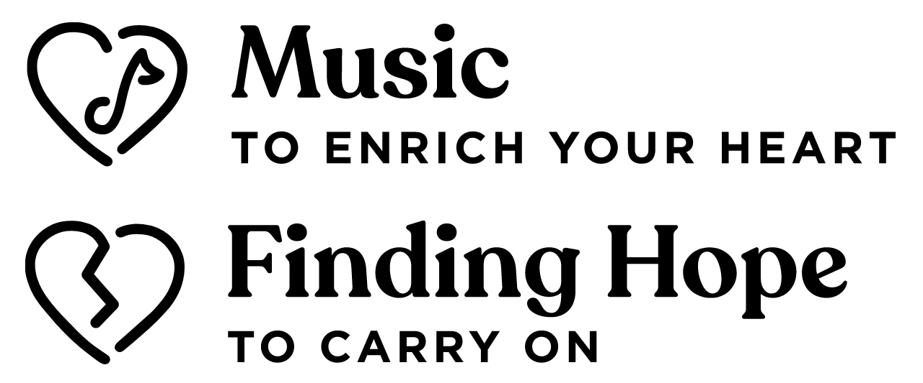Contact Charlie & Jill by calling or writing their office at:
Joyful Word Ministries
P.O. Box 2733
Ponte Vedra Beach, FL 32004-2733
USA
(US) 800-326-0741
(Int’l) +1-636-405-0050
Website: www.CharlieandJill.com
Email: mail@charlieandjill.com

